
Name: …Solutions…….......……
Resource Free | /30 | %
Resource Rich | /27 | %
Total | /57 | %

Mathematics Methods, Year 12, 2018
Test 1 – Further differentiation and applications

30 minutes working time.
Calculator Free Section (no notes, no calculators)
SCSA Formula sheet allowed

1. [6 marks: 2, 2, 2]
Determine for each of the following.

a) $f\left(x\right)=\sqrt{2x}-\frac{3}{x}$

$$\frac{dy}{dx}=\frac{\sqrt{2}}{2\sqrt{x}}+\frac{3}{x^{2}}$$

b) $f\left(x\right)=\frac{x-2}{x+1}, x≠-1$

$\frac{dy}{dx}=\frac{1\left(x+1\right)-1(x-2)}{{(x+1)}^{2}}$

$=\frac{3}{{(x+1)}^{2}}$

c) $y=\sqrt{3x+2}$

$$y={(3x+2)}^{\frac{1}{2}}$$

$\frac{dy}{dx}=\frac{1}{2}{\left(3x+2\right)}^{-\frac{1}{2}}(3)$

$\frac{dy}{dx}=\frac{3}{2\sqrt{\left(3x+2\right)}}$

2. [3 marks]
Use $y=\sqrt{3x}$ and $y=x^{\frac{3}{2}}$to comment on whether the derivative of the product of two functions is equal to the product of their derivatives.

$\left(\sqrt{3x}\right)\left(x^{\frac{3}{2}}\right)=\sqrt{3}x^{2}$
$\frac{d}{dx}\left(\sqrt{3}x^{2}\right)=2\sqrt{3}x$

If $=\sqrt{3x}$ , $y^{'}=\frac{\sqrt{3}}{2\sqrt{x}}$

If $y=x^{\frac{3}{2}}$, $y^{'}=\frac{3\sqrt{x}}{2}$

$\left(\frac{\sqrt{3}}{2\sqrt{x}}\right)\left(\frac{3\sqrt{x}}{2}\right)=\frac{3\sqrt{3}}{4}$

∴ The derivative of the product of two functions does not (necessarily) equal the product of their derivatives.

3. [3 marks]

If $y=xf^{'}\left(x\right)$, show that $\frac{d^{2}y}{dx^{2}}=xf^{'''}\left(x\right)+2f''(x)$.

$\frac{dy}{dx}=\left(1\right)\left(f^{'}\left(x\right)\right)+(x)(f^{''}\left(x\right))$
$\frac{d^{2}y}{dx^{2}}=\left(0\right)\left(f^{'}\left(x\right)\right)+\left(1\right)\left(f^{''}\left(x\right)\right)+\left(1\right)\left(f^{''}\left(x\right)\right)+(x)f'''(x))$
$\frac{d^{2}y}{dx^{2}}=x\left(f^{'''}\left(x\right)\right)+2f''(x)$

4. [4 marks]

Calculate the minimum and maximum values of $x^{2}(6-x)$ in the interval $1≤x≤5$.

If ${f\left(x\right)=x}^{2}(6-x)$, ${f^{'}\left(x\right)=12x-3x}^{2}=3x(4-x)$
$3x\left(4-x\right)=0$ when $x=0$ or $4$.
So the only TP over the interval is when $x=4$.
$f\left(1\right)=1^{2}\left(6-1\right)=5$ $f\left(4\right)=4^{2}\left(6-4\right)=32$ $f\left(5\right)=5^{2}\left(6-5\right)=25$
So the minimum value is 5 and the maximum value is 32.

5. [2 marks]
A particle leaves the origin when $t=1$ and moves in a straight line with velocity at any time $t$ seconds, where $t≥1$, given by
${v\left(t\right)= \frac{t^{2}}{4}+\frac{4}{t}-\frac{7}{4} ms}^{-1}$
Determine the time when the acceleration of the particle is zero.
$a\left(t\right)=\frac{dv}{dt}=\frac{t}{2}-\frac{4}{t^{2}}$
$\frac{t}{2}-\frac{4}{t^{2}}=0$⇒ $t^{3}=8$ ⇒ $t=2$ s

6. [5 marks]
Given that $y=\sqrt{x}$ , use $x=100$and the incremental formula $δy=\frac{dy}{dx}×δx$ to determine an approximate value for $\sqrt{104}$.

$x=100$, $δx=4$

$\frac{dy}{dx}=\frac{1}{2\sqrt{x}}$

$δy=\frac{1}{2\sqrt{x}}×δx$

$δy=\frac{1}{2\sqrt{100}}×4=0.2$

$$\sqrt{104}≈\sqrt{100}+0.2$$

∴ $\sqrt{104}≈10.2$

7. [7 marks: 1, 1, 1, 1, 3]
Given ,

a) Evaluate:

(i) f (2) 9

(ii) f ′(2) 0

(iii) f ′′(2) -2

b) i. Sketch the graph of f (x) over the domain on the axes provided.
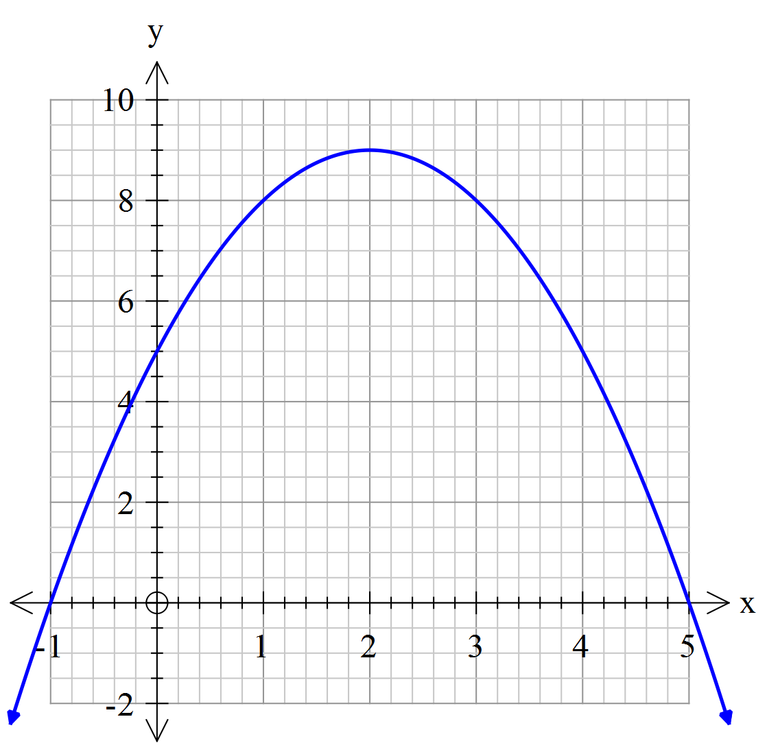

ii. With reference to your sketch, explain the significance of each answer from part a.

(i) f (2) is the y value of the turning point.

(ii) f ′(2) suggests the function has a stationary point at x = 2.
i.e. the gradient of the tangent at (2, 9) is zero.

(iii) f ′′(2) suggests that the function is concave down at x = 2.

END OF CALCULATOR FREE SECTION

